Grade: 6. Light, Shadows and Reflections Date:14.6.23
WORKSHEET – I

I.State True or False
1) Light travels in a straight line in a vacuum
2) A Shadow can be colored
3) The image formed in the pinhole camera is both erect and inverted
4) Clear glass does not cast shadows
5) A periscope is an instrument used for observing objects from a hidden position
6) M Moon is a luminous object
II.Fill in the Blank
7) The phenomenon by which we see our face in the mirror is called _____.
8) Sun is an ________ object as we are able to see other things.
9) A _______ eclipse occurs when the Earth comes between the Sun and the moon in a straight line.
10) Wooden piece is an _________ object.
11) _______ and ______ are two types of shadows.
12) The objects which partially allow light to pass through them are called ________________.
13) Speed of light in air is _______ .
III.Match the column
S.no | Column A | Column B
14 | Translucent | Wood
15 | Opaque | Torch bulb
16 | Transparent | Butter paper
17 | Luminous | Glass
 |  | Water
 |  | Sun

IV.Solve the below crossword
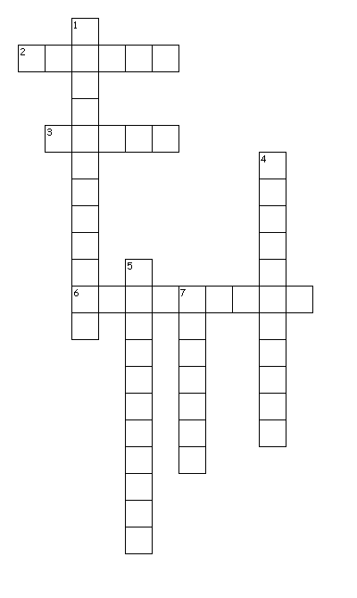
Across
2. These objects does not allow light to pass through them
3. it travels in straight line
6. it is a device to see hidden corners
Down
1. This device uses reflection to create beautiful picture
4. These objects allows light to pass fully
5. These objects allow the light to pass partially
7. It is formed when opaque objects come in the path of light

Grade: 6. Light, Shadows and Reflections Date: 14.6.23
WORKSHEET – II
I. Tick the Correct Option
1. Shadows form because:
(a) opaque objects reflect light (b) opaque objects do not allow light to pass through them
(c) light travels in one direction from a source (d) light bends around an opaque object
2. Which English letters do not show lateral inversion.
(a) I,O,U (b) N,Z,X (c) I,X,E (d) A,E,I
3. Which of the following is a non-luminous body?
(a) Moon (b) Sun (c) Bulb (d) Burning candle
4. The colour of a shadow is :
(a) black (b) green (c) grey (d) cannot say
5. The speed of light in vacuum is :
(a) 3 × 10⁸ m/sec (b) 2 × 10⁹ m/sec (c) 1.5 × 10⁸ m/sec (d) none of these
II. Fill in the Blanks
1. Light is a form of ……………………. .
2. A glowing tubelight is an example of …………………… source of light.
3. The shadow of an object is always of ………………. colour.
4. The …………………… is a luminous object.
5. Light travels in a ……………….. line.
III. State True or False
1. The moon is a natural source of light. ……………….
2. Light always travels in a straight line. ……………….
3. Pinhole camera works on the principle of rectilinear propagation of light. ………………….
4. Stars are luminous bodies. …………………
5. Shadow of an object is formed in the direction. opposite to that of the light source. …………….
IV. Match the following
‘A’ | ‘B’
1. Brick | a. A natural source of light
2. Tubelight | b. Region of partial darkness
3. Sun | c. Shadow cast by heavenly bodies
4. Eclipse | d. An opaque object
5. Penumbra | e. An artificial source of light
V. Write the letter in the blanks given below with the help of corresponding hints.
1. T _ _ _ S _ _ _ _ _T.
Hint: Through these objects, we can see but not very clearly.
2. _ _M _ N _ _ S.
Hint: Sun is in this category of sources of light.
3. S _ R _ _ _.
Hint: We can’t obtain an image without this.
4. R _ _ _ C _ _ _ _ .
Hint: Mirror gives us clear images because of this phenomenon.

